Effect of Temperature on Catalase Activity Rate

Abstract
The experiment we preformed was to see how temperature effects the reaction of enzyme and its substrate. We used hydrogen peroxide and catalase to carry out our experiment. Our hypothesis was that the higher the temperature of the peroxide the faster the reaction. In the experiment we tested three temperatures of the peroxide.
Background
The purpose of this is experiment is to find out the effects of varying temperature on the rate of Catalase on Hydrogen Peroxide (H202). We are doing this because it was assigned to us by the Life Science Academy and we have no choice. The importance of this is to investigate and learn about how enzymes act and react to their substrates. This would show how enzymes would react in our bodies under certain conditions, such as a fever or hypothermia.
Research that has been done on this has shown that they heat from the heated hydrogen peroxide creates more kinetic energy, making the enzymes move faster in the solution so they collide with more substrates, creating a faster reaction. The opposite is present with the cold water, slowing the enzymes, so they collide at a slower rate. The room temperature would act as a control to see how everything would compare versus normal conditions.
Hypothesis
Our hypothesis is if the temperature is higher, the rate of the reaction would be faster, and if the temperature is lower, the rate of the reaction will be slower than the room temperature, or control.

Results
Room Temperature
The data that was collected for the Hydrogen Peroxide at room temperature (23˚C) was much more surprising than we were expecting. For the first few seconds, there was an increase in pressure within the flask that showed that the catalase was successfully breaking the hydrogen peroxide into oxygen gas and water. However, at 4 seconds, the pressure exponentially increased until the stopper popped off (Figure 1). We had to rush to place the stopper back on the flask, where the pressure continued to decrease. The peak of this set of data was at 4 seconds and was 129.11 kPa

Figure 1: Room Temperature
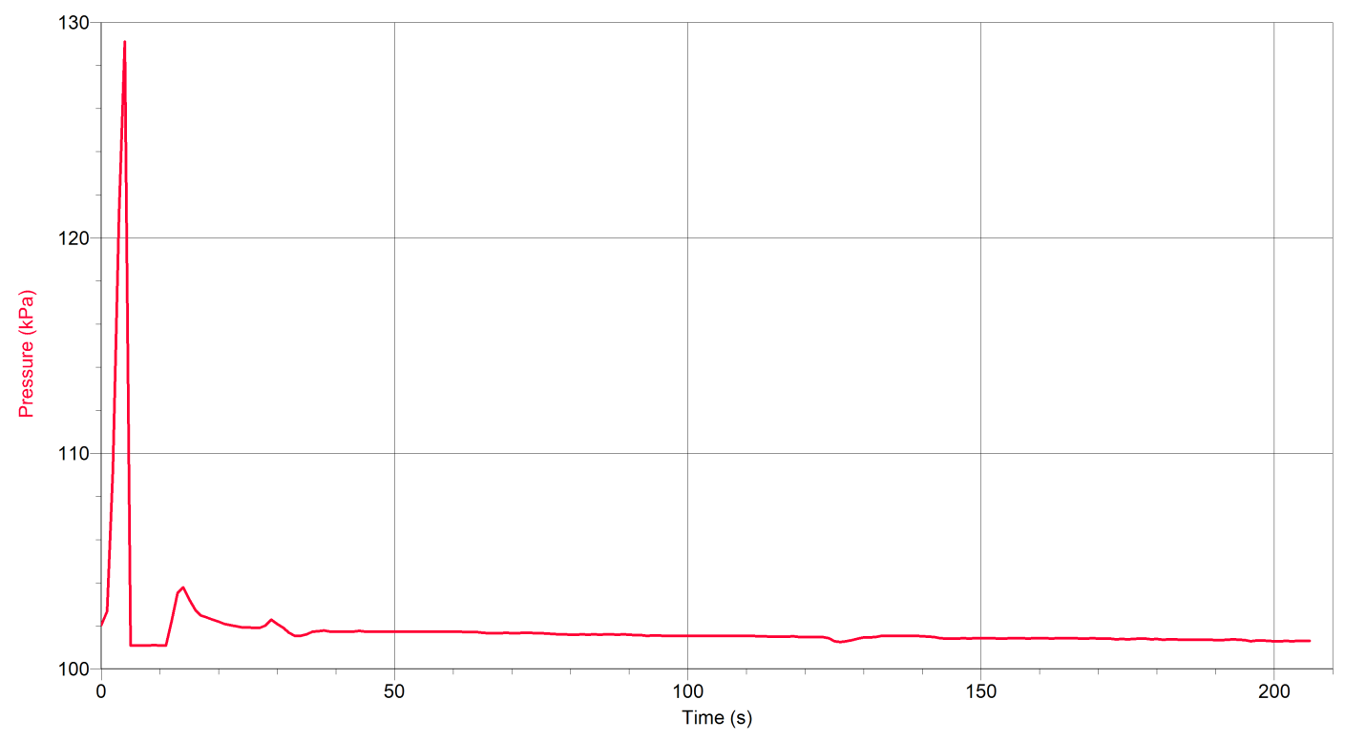
Hot Water
The results of the hydrogen peroxide at 80˚C proved to be inaccurate because we were forced to increase the RPM to 700 instead of the pre-determined 125. The gas pressure according to the data would increase and then decrease at an interval and continued on like that for the entire course of the trial (Figure 2). The blue line found on the graph is the “correct” line of data to follow. The results were inconclusive as to whether or not the higher temperatures aided the breakdown of the hydrogen peroxide. The peak of the inaccurate data was 101.92 kPa.
Figure 2: Hot Water (80˚C)
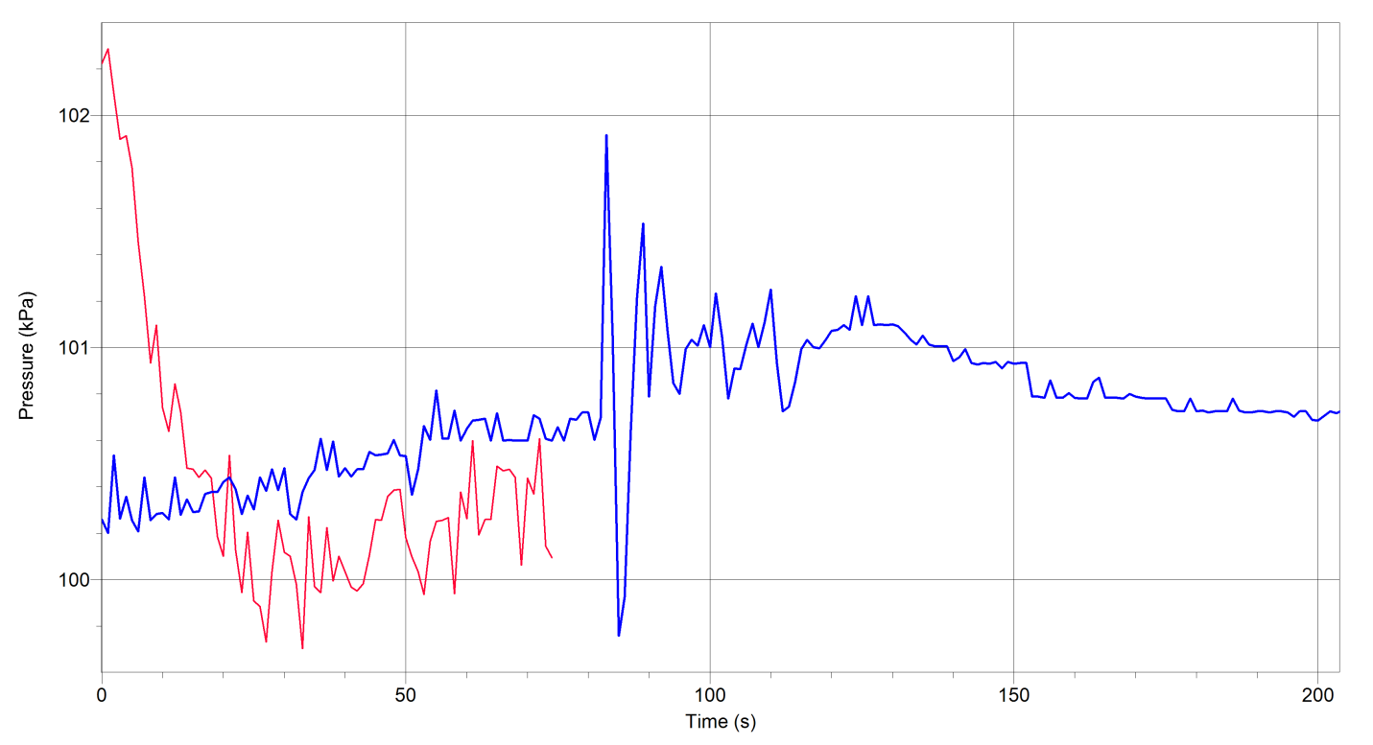
Cold Water
The final test we performed involved an ice bath that cooled the hydrogen peroxide to a chilly 6˚C. We expected the line of data to increase at a slower rate than that of the room temperature. However, the gas pressure of the cooler hydrogen peroxide increased until it peaked at 104.79 kPa, and it remained up at the peak until the trial ended (Figure 3).
Figure 3: Cold Water (6˚C)
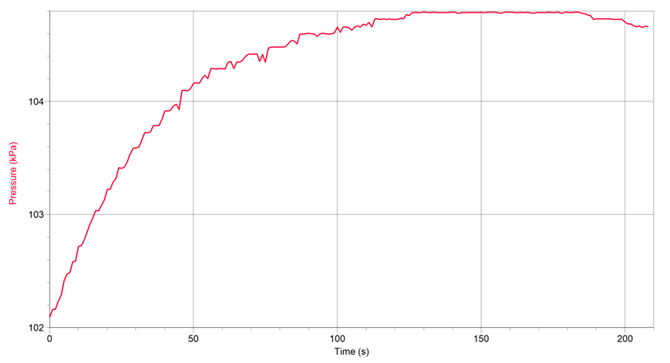

Materials and Methods
Materials
- 125 mL Erlenmeyer flask
- 1.5% H₂O₂ solution
- Stirring bar
- Magnetic Stirrer
- Ring stand
- Utility Clamp
- Vernier Gas Pressure Sensor
- Lab Quest Mini
- Computer with Internet access and Vernier Logger Pro® software
- Laboratory journal
- Catalase solution, 200 units/mL
- Thermometer
- Two-hole rubber stopper assembly
- Tubing with Luer-lock connecters
- 200-20 µL micropippetor
- 200 µL micropipette tips

Methods
Room Temperature
- Measure 50 mL of 1.5% H₂0₂ at 23°
- Place stir bar in flask
- Position flask over magnet
- Connect the tubing to the two-holed rubber stopper, keeping it closed tight
- Using the micropipette, add 100 mL of the enzyme into the contents
- Tightly seal the flask with the stopper
- Insure flask is properly positioned
- Start data collection
- Don’t let pressure exceed 130 pa
- Stop data collection at 200 seconds
Hot Water
- Repeat previous step 1.
- Place flask with H₂O₂ into hot water bath until it reaches 80°
- Repeat steps 2.-10. from Room Temperature steps
Cold Water
- Repeat previous step 1.
- Place flask with H2O2 into hot water bath until it reaches 80°
- Repeat steps 2.-10. from Room Temperature steps
Discussion
In this experiment, our hypothesis was found false because it showed that the rate of reaction was faster at room temperature. However, our results were inaccurate in the hot water experiment because the stopper had a leak and to move the reaction along we had to turn up the rpm to 700 instead of 125.
Conclusion
The highest rate of reaction found in this experiment was found in the room temperature experiment.

Citations
Azizi, Shabnum. "How Does Temperature Affect the Reaction Rate between Catalase and Hydrogen Peroxide?" California State Science Fair. 1 Jan. 2006. Web. 26 Jan. 2015. <https://www.usc.edu/CSSF/History/2006/Projects/J0402.pdf>.

"Effect of Temperature on Catalase Activity." Knowledge Bank. 1 Jan. 2011. Web. 26 Jan. 2015. <https://kb.osu.edu/dspace/bitstream/handle/1811/3787/V50N06_273.pdf;jsessionid=67C3BB579E36DBF907B27E66CE4A61B1?sequence=1>.

"Ybor City Campus 1025C Laboratory Exercise 3: Characteristics of Enzymes Introduction."Hillsborough Community College. 1 Jan. 2014. Web. 26 Jan. 2015. <http://www.hccfl.edu/media/571431/4-enzyme activity.pdf>.

