Introduction
Our team of forensic anthropologists – Ben, Chelsea, Marie, Allison, and Cameron – was given various bones from a body found in the park. We examined the skull, pelvis, humerus, and femur of the body found. We were able to determine the age, height, gender, and ethnicity of the person by taking measurements of the bones and performed various calculations.

BONE DETECTIVES

Age
When a human is first born, we have around 405 bones in our body. But as we age our bones go through something called fusing. Fusing is where bones come together or join. After the bones fuse, the adult skeleton will have a total of around 206 bones. Our group had observed bones that belonged to a man that were the age between eighteen years and twenty years old. To determine this we observed mainly the femur, humerus, and pelvis. The pelvis showed the fusing process has begun in the middle of the pelvis but has not completed yet. Then while looking at the femur we noticed that the greater and lesser trochanter have appeared and are joined to the shaft. Both of the trochanters are located between the head and the shaft of the femur. The condyle is also shown to be joined to the shaft. While we looked at the humerus we noted that not only did the head, trochlea, and external condyle blend with the shaft but also that the internal condyle united also. Also joining with the shaft was the upper epiphysis. All of these observations show that he is in his last teenager years but not so old that his bones are completely fused and done growing.

Height
To find the height of our person, we used the femur and humerus bones. The formulas we have used to find the height are broken down by gender and race. The maximum lengths of the femur and humerus are needed to plug in to those equations. The maximum length of the femur is 430 mm or 43 cm. By using the femurs measurements and the equations the forensic anthropologists’ equations we found the maximum height and the minimum heights of our person. The maximum was 5’7” and the minimum height was 5’5”. Then to find the probable height using the humerus we needed to find the maximum length of it which is 290 mm or 29cm. After solving all of the equations we found that using the humerus, our person should be between the height 4’7” and 5’5.5”. Finally after taking the maximum and minimum values and dividing each by 2.54 we found that our person should be between the heights of 5’ and 5’8”.

Gender
The gender of a set of bones or remains can easily be determined if you know the criteria of bone shape, expression, angle etc. At the beginning, the remains we found were of an unknown person. The gender, age, height, and ethnicity were not known. Based on the pelvis, skull, and femur, however, the gender came easily. The pelvis was heart-shaped, a definite male characteristic, as a female’s must be round for them to give birth properly. The sciatic notch was 55°; another male characteristic. The femur length indicated that the remains were male. The main inconsistencies were found in the skull and humerus. The eye orbits (eye sockets) were round, where a male’s is generally squarer, and the zygomatic process was not expressed. All measurements of the humerus indicated that the remains were female. The majority of all observations and measurements, however, pointed towards male.

Ethnicity
The ethnicity was a little more white-dominant. One could easily fit their finger into the curvature of the femur, indicating a white person. The nasal index (width divided by height of nasal opening) indicated someone of Asian descent; however, the prominent nasal spine, sharp nasal silling, straight prognathism, and somewhat square eye sockets all pointed towards Caucasoid remains.

Further Analysis

Facial Reconstruction
Facial Reconstruction is a very useful technique used by forensic anthropologists to help identify a set of skeletal remains. The reproduction of facial features is based upon the average thickness of soft tissues over various parts of the skull and jaws. Fortunately for forensic anthropologists, young people, older people, males, females and different ethnicities tend to have different distributions of soft tissues, making the likelihood of producing an identical reconstruction far more feasible. In the case of our missing people, this technique should have been very effective at identifying who the remains belonged to. We would have been able to at least get a general idea of what our victim had once looked like.

DNA Analysis
DNA Analysis may also be used to identify skeletal remains. Because no one person’s DNA is the same as another person's, this technique is very useful. All of our cells contain our unique genetic code, so any form of cell may be used, such as: skin, bone, hair, etc. From these tests, we are able to learn all about who the remains belong to. In DNA Analysis, a sample of the bone is taken and processed to isolate the DNA strand. Then, a sample is given by who the investigators believe the remains are from. The DNA is compared using Gel Electrophoresis, and, depending on how similar the results are between the remains and the missing, a positive identification may be made. This method is one of the most accurate that can be used to identify bone remains. DNA never lies because no two people have the same DNA.

Time of Death
Not only can age, gender, ethnicity, and height be determined from the skeletal remains of a victim, but time of death may also be determined. The condition of the bones found and the amount of flesh remaining will vary depending on time, exposure, temperature, and the surrounding environment. For example, if the victim was dumped into a boggy area and buried, then the body will be preserved for a longer period of time because the mud helps preserve the flesh and bone. Calculating the time of death from skeletal remains is very useful because it helps you to narrow down possible victims based on when they disappeared compared to how long the bones have been sitting where they are. This information is very important and can save a lot of time in determining who the bone remains belong to.

Conclusion
With our findings we determined that the missing person was between the ages of 18 and 20 by examining how well grown all of the bones were and if they were all fused completely. Once we measured the bones and calculated them accordingly we were able to decide that the missing person was around 5’8”. When we examined the pelvis we were able to classify the person as male because of how the coccyx was angled. And lastly, we said that the young missing male was Caucasian because of many angular characteristics found on the skull.
To further our investigation we would need to call the families of missing persons that match our findings and ask if they might be able to provide a DNA sample so that we could compare.

DNA ANALYSIS

Data Analysis
The DNA results were the same when digested by Enzyme 1, HINDIII (See lanes D and F). When digested by Enzyme 2, PSTL, the DNA results of missing person #2 matched with those of the skeleton found, whereas the DNA from missing person #1 differed. This concludes that the skeleton belonged to missing person #2.
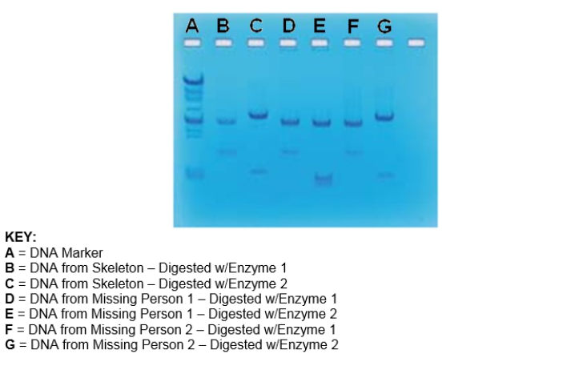

Conclusion
The information that our group obtained was studied and calculated to find our results. We discovered through looking at the indentions and the texture of the skull, including the small hook on the back of the skull, that our victim was a male. The pelvis told us that since the sacrum was longer and angled into the pelvis more that the victim was a male. The pelvis also told us that since the pubic symphysis was starting to form that the victim was around the age of 18-20. The DNA from the gel electrophoresis confirmed that the DNA matched with the missing person #2.

